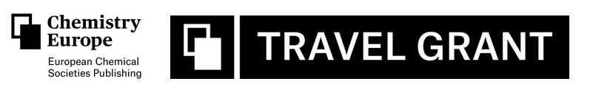
APPLICATION FORM:
Personal Information:
Full Name:
Date of Birth:
Nationality:
Email Address:
Phone Number:
Mailing Address:
Current Position/Job Title:
Affiliated Institution:
Research Interests:

Eligibility Criteria:
Date of achievement of the PhD (must be later than 10th May 2017):
Member of KVCV:

Proposed Research Visit:
Host Institution:
Country of Host Institution:
Proposed Duration of Visit (1-2 months):
Brief Proposal (Describe the research activities you plan to undertake during your visit, how this collaboration will benefit your career and research, and how it aligns with the objectives of the Chemistry Europe Travel Grant):
max 5000 characters space included.
Supporting Documents:
PhD certificate
Curriculum Vitae (CV)
Acceptance Letter from the Principal Investigator (PI) at the Host Institution
List of Significant Publications (Please provide a list of significant publications by both yourself and the PI, published during last 7 years)
Declaration:
I confirm that all the information provided in this application is accurate to the best of my knowledge. I understand that incomplete applications or applications received after the deadline will not be considered.

Signature: _______________________

Date: _______________________

Submission Instructions:
Please submit the completed application along with the supporting documents to KVCV (contact@kvcv.be) by November 30th, 2024. The selection process will be conducted by committees appointed by KVCV and SRC, and final awardees will be selected by Chemistry Europe. If you have any questions or need further assistance, please reach out to KVCV at contact@kvcv.be.

Deadline for Submission: November 30th, 2024
Note: Failure to adhere to the guidelines and requirements outlined in the application instructions may result in disqualification from consideration for the Chemistry Europe Travel Grant.

